SELECT nama_obat, qty, harga, total_bayar

FROM Obat O

JOIN transaksi_detail S ON S.id_obat = O.id

JOIN transaksi I ON I.id = S.id_transaksi

ORDER BY qty;

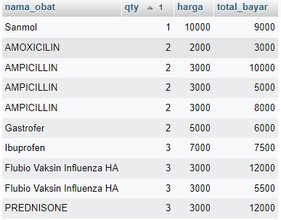

SELECT nama_obat, qty, harga, total_bayar

FROM Obat O

JOIN transaksi_detail S ON S.id_obat = O.id

JOIN transaksi I ON I.id = S.id_transaksi

WHERE harga > 5000;

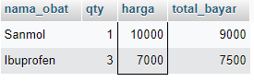

SELECT nama_obat, qty, harga, total_bayar

FROM Obat O

JOIN transaksi_detail S ON S.id_obat = O.id

JOIN transaksi I ON I.id = S.id_transaksi

WHERE total_bayar > 10000;

